What is a TCP port?

The TCP port is a unique number assigned to different applications. For example, we have opened the email and games applications on our computer; through email application, we want to send the mail to the host, and through games application, we want to play the online games. In order to do all these tasks, different unique numbers are assigned to these applications. Each protocol and address have a port known as a port number. The [TCP (Transmission Control Protocol)](https://www.javatpoint.com/tcp) and UDP (User Datagram Protocol) protocols mainly use the port numbers.

A port number is a unique identifier used with an IP address. A port is a 16-bit unsigned integer, and the total number of ports available in the [TCP/IP model](https://www.javatpoint.com/computer-network-tcp-ip-model) is 65,535 ports. Therefore, the range of port numbers is 0 to 65535. In the case of TCP, the zero-port number is reserved and cannot be used, whereas, in UDP, the zero port is not available. IANA (Internet Assigned Numbers Authority) is a standard body that assigns the port numbers.

**Example of port number:**

**192.168.1.100: 7**

In the above case, **192.168.1.100** is an IP address, and **7** is a port number.

To access a particular service, the port number is used with an [IP](https://www.javatpoint.com/ip-full-form) address. The range from 0 to 1023 port numbers are reserved for the standard protocols, and the other port numbers are user-defined.

Why do we require port numbers?

A single client can have multiple connections with the same server or multiple servers. The client may be running multiple applications at the same time. When the client tries to access some service, then the IP address is not sufficient to access the service. To access the service from a server, the port number is required. So, the transport layer plays a major role in providing multiple communication between these applications by assigning a port number to the applications.

Classification of port numbers

**The port numbers are divided into three categories:**

* **Well-known ports**
* **Registered ports**
* **Dynamic ports**

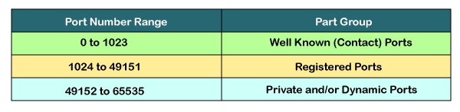

Well-known ports

The range of well-known port is 0 to 1023. The well-known ports are used with those protocols that serve common applications and services such as [HTTP (hypertext transfer protocol)](https://www.javatpoint.com/http-tutorial), IMAP (Internet Message Access Protocol), SMTP (Simple Mail Transfer Protocol), etc. For example, we want to visit some websites on an internet; then, we use [http](https://www.javatpoint.com/computer-network-http) protocol; the [http](https://www.javatpoint.com/http) is available with a port number 80, which means that when we use http protocol with an application then it gets port number 80. It is defined that whenever [http](https://www.javatpoint.com/http-full-form) protocol is used, then port number 80 will be used. Similarly, with other protocols such as [SMTP](https://www.javatpoint.com/simple-mail-transfer-protocol), IMAP; well-known ports are defined. The remaining port numbers are used for random applications.

Registered ports

The range of registered port is 1024 to 49151. The registered ports are used for the user processes. These processes are individual applications rather than the common applications that have a well-known port.

Dynamic ports

The range of dynamic port is 49152 to 65535. Another name of the dynamic port is ephemeral ports. These port numbers are assigned to the client application dynamically when a client creates a connection. The dynamic port is identified when the client initiates the connection, whereas the client knows the well-known port prior to the connection. This port is not known to the client when the client connects to the service.

TCP and UDP header

As we know that both TCP and UDP contain source and destination port numbers, and these port numbers are used to identify the application or a server both at the source and the destination side. Both TCP and UDP use port numbers to pass the information to the upper layers.

**Let's understand this scenario.**

Suppose a client is accessing a web page. The TCP header contains both the source and destination port.

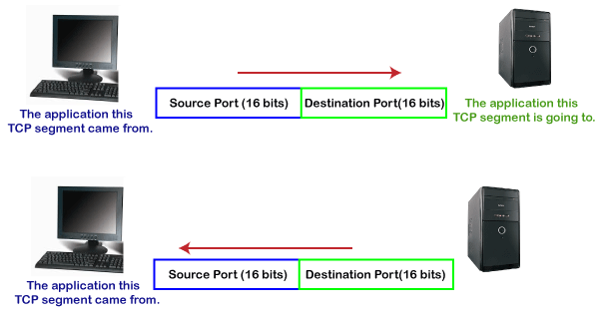

Client-side

**In the above diagram,**

**Source Port:** The source port defines an application to which the TCP segment belongs to, and this port number is dynamically assigned by the client. This is basically a process to which the port number is assigned.

**Destination port:** The destination port identifies the location of the service on the server so that the server can serve the request of the client.

Server-side

**In the above diagram,**

**Source port:** It defines the application from where the TCP segment came from.

**Destination port:** It defines the application to which the TCP segment is going to.

**In the above case, two processes are used:**

**Encapsulation:** Port numbers are used by the sender to tell the receiver which application it should use for the data.

**Decapsulation:** Port numbers are used by the receiver to identify which application should it sends the data to.

Let's understand the above example by using all three ports, i.e., well-known port, registered port, and dynamic port.

**First, we look at a well-known port.**

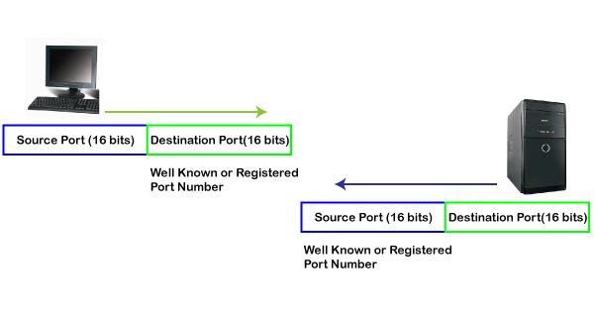

The well-known ports are the ports that serve the common services and applications like http, ftp, smtp, etc. Here, the client uses a well-known port as a destination port while the server uses a well-known port as a source port. For example, the client sends an http request, then, in this case, the destination port would be 80, whereas the http server is serving the request so its source port number would be 80.

**Now, we look at the registered port.**

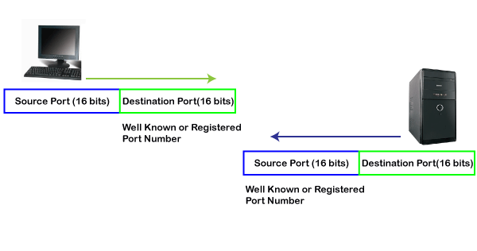

The registered port is assigned to the non-common applications. Lots of vendor applications use this port. Like the well-known port, client uses this port as a destination port whereas the server uses this port as a source port.

**At the end, we see how dynamic port works in this scenario.**

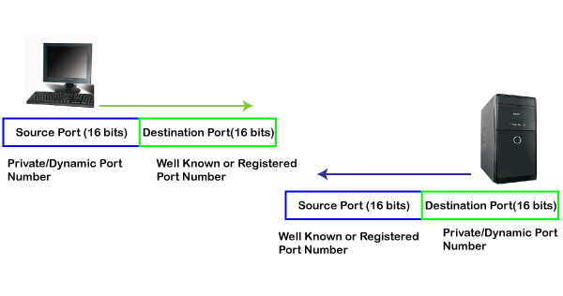

The dynamic port is the port that is dynamically assigned to the client application when initiating a connection. In this case, the client uses a dynamic port as a source port, whereas the server uses a dynamic port as a destination port. For example, the client sends an http request; then in this case, destination port would be 80 as it is a http request, and the source port will only be assigned by the client. When the server serves the request, then the source port would be 80 as it is an http server, and the destination port would be the same as the source port of the client. The registered port can also be used in place of a dynamic port.

**Let's look at the below example.**

Suppose client is communicating with a server, and sending the http request. So, the client sends the TCP segment to the well-known port, i.e., 80 of the HTTP protocols. In this case, the destination port would be 80 and suppose the source port assigned dynamically by the client is 1028. When the server responds, the destination port is 1028 as the source port defined by the client is 1028, and the source port at the server end would be 80 as the HTTP server is responding to the request of the client.